海盗船 --- 手机遥控功能

在完成基础功能后，我们对机器人来个升级，给它增加手机蓝牙遥控。可通过手机轻松遥控小车，更可给小车增加炫酷的LED灯光效果。结合我们全新打造的手机端APP，相信你一定会对它爱不释手。并且我们对蓝牙的代码做了优化，更方便初学者使用。

As the robot has been enabled to perform the basic tasks, we now upgrade it with one more feature, namely, control the robot from your cellphone via Bluetooth.

**准备工作：**

**Preparation**

* iPhone 或者 iPad × 1

iPhone or iPad × 1

* [走你APP](https://itunes.apple.com/cn/app/zou-ni-lan-ya4.0-kong-zhi-qi/id950937437?mt=8) × 1

GoBLE APP × 1



注意：需要 iOS 8.1 或更高版本。此App已针对iPhone 5、iPhone 6 和 iPhone 6 Plus 优化。

Notice: You should at least have iOS 8.1 installed on your phone. Since optimized, you can easily enjoy the app on iPhoen5, iPhone 6 or iPhone 6 Plus.

由于我们目前只开发了iOS的APP，所以安卓用户暂时没有可直接使用的APP。iPhone用户可在Apple Store下载GoBLE的APP。下载完成后，打开APP，如果呈现出如下所示的界面，说明你APP下载正确了！

Currently, we have only brought the app to iOS, but it is not available for an Android. For iPhone users: please download GoBLE from the App Store. If the screen is shown as the photo below when you open the app, GONGRATULATIONS! You’ve got the right APP!

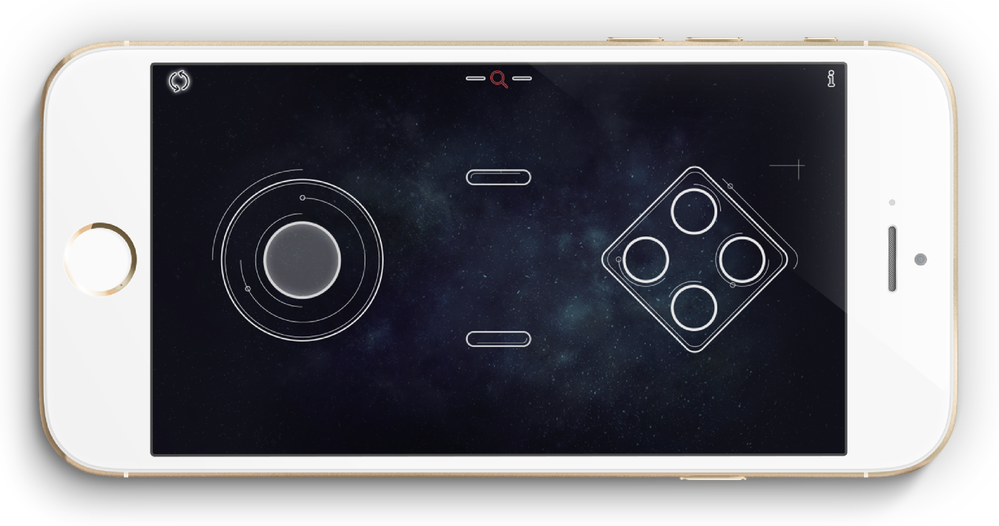

**输入测试代码**

**Type in the Testing Code**

插上USB线，你可在软件包中找到GoBLE_Test.ino的代码，这是一段测试代码。还不能遥控小车的，只是可以从电脑端看到手机发出来的信号。下载一下看了就知道了。下载代码前，不要忘记加载一下遥控的GoBLE的库。下载成功后，信息框会显示Done uploading。

Please connect the iPhone to your computer using USB cable. The testing code named GoBLE_Test.ino can be found in the software package. It only enables you to check the signal from your iPhone on PC. DOWNLOAD IT & CHECK IT OUT. Don’t forget to load GoBLE’s KU before you download the testing code. Once downloaded, the “Done uploading” notice would pop up.

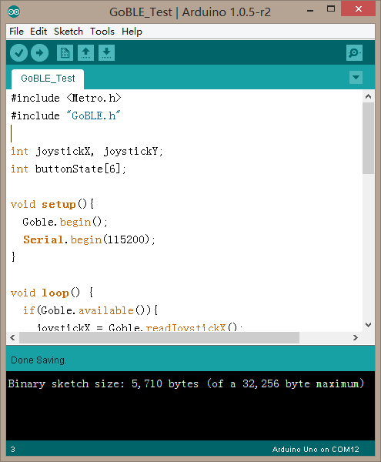

**蓝牙调试**

**Bluetooth Setup**

下载完代码，我们需要将手机和蓝牙进行配对。首先 , 记得打开手机蓝牙。然后，打开走你APP，会出现如下界面。

Now let’s start the Bluetooth pairing: connecting the robot to your iPhone. Please turn on the Bluetooth on your iPhone and then open the GoBLE app. Your screen would look like this!

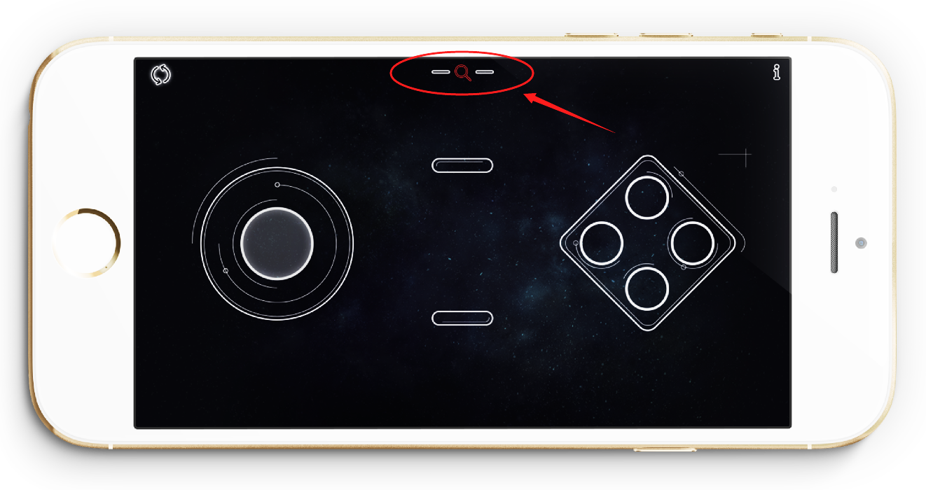

点击蓝牙搜索键（红色放大镜）。此时，会显示所有蓝牙设备，选择Romeo BLE对应的蓝牙设备名称，进行连接。

Click the button for Bluetooth search (the one within the red circle). Then, choose one named Romeo BLE out of all the Bluetooth devices listed on the screen. Click CONNECT and start pairing.

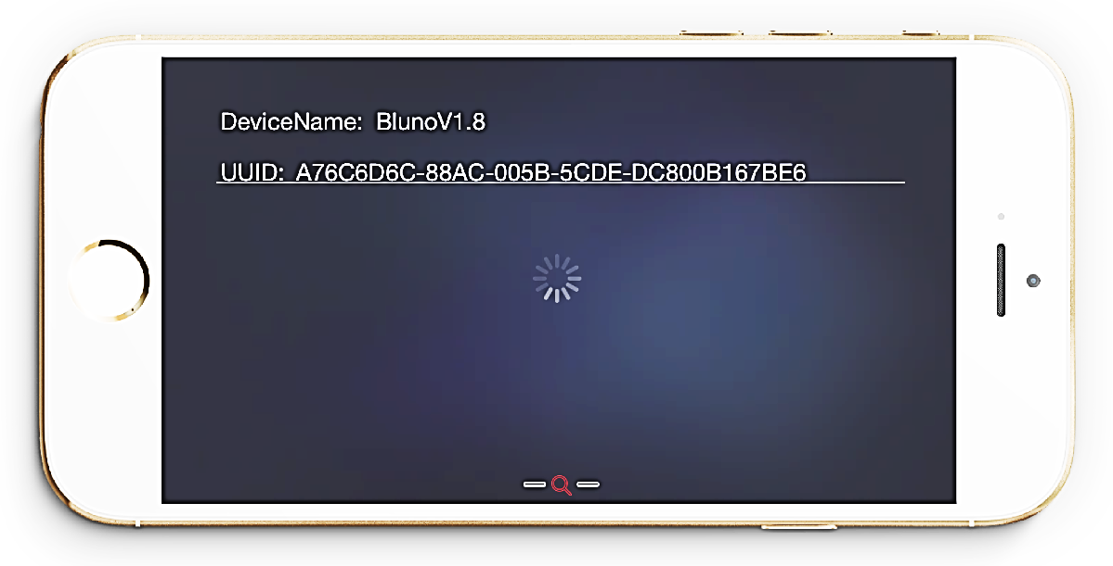

连接成功后，蓝牙搜索键的会由红色转变为绿色。如下图所示：

Once connected, the button for Bluetooth search would be in green just as it is shown in the photo below.

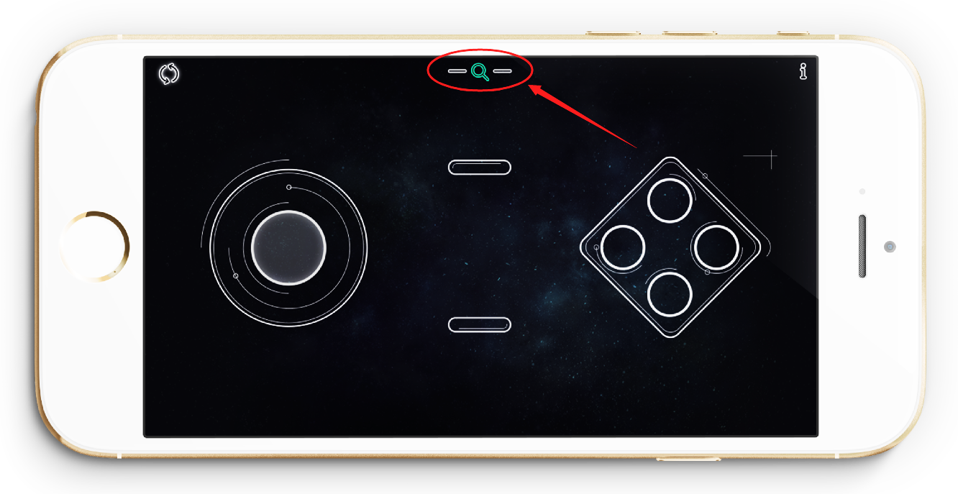

连接成功后，Roemo BLE上的绿色Link会点亮，此时说明你手机和控制器连接上了。

Once connected, the green link on Roemo would be brightening, meaning that your iPhone have been connected to the controller.

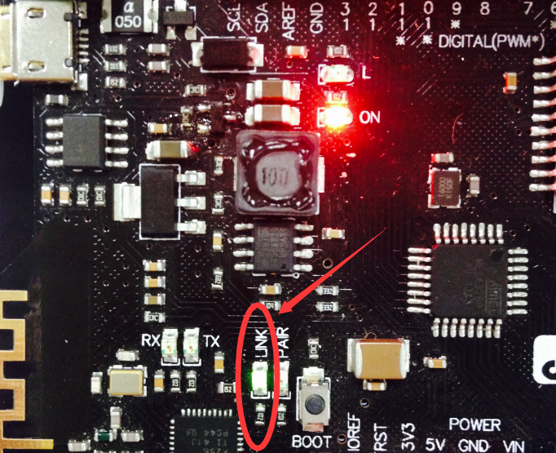

完成连接后，我们就可以测试控制器接收信号的情况了。回到Arduino IDE的界面，点击右上角Serial Monitor（串口监视器）。

Now let’s test if the controller can successfully receive signal from your iPhone. Go back to the Arduino IDE interface and click the Serial Monitor on the upper right-hand corner.

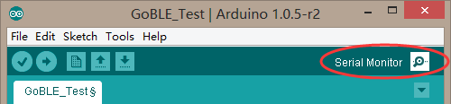

会弹出如下的对话框，先将串口的波特率设置为115200，就是下图红色圈出的部分。

A dialogue as it is shown in the picture below would pop up. The baud rate of serial port shall be set to be 115200 as it is shown in the red circle below.

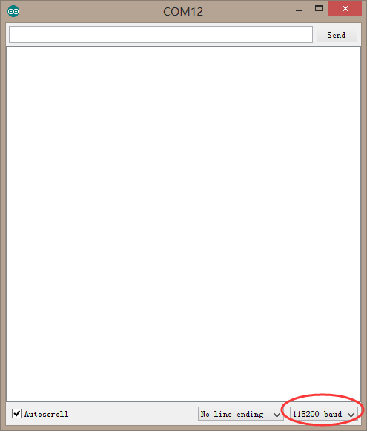

此时，拿出你的手机，任意的滑动摇杆，或者点击按钮。不出意外的话，你可以从串口监视器中看到，对应的数值，Joystick Value代表的是摇杆的数值。Button ID则对应显示你按下的哪个按键，

Now take out your iPhone and randomly swipe the joystick or click the button. Normally, a figure, Joystick Value, will be shown on the Serial Monitor. Button ID means the button you just clicked.

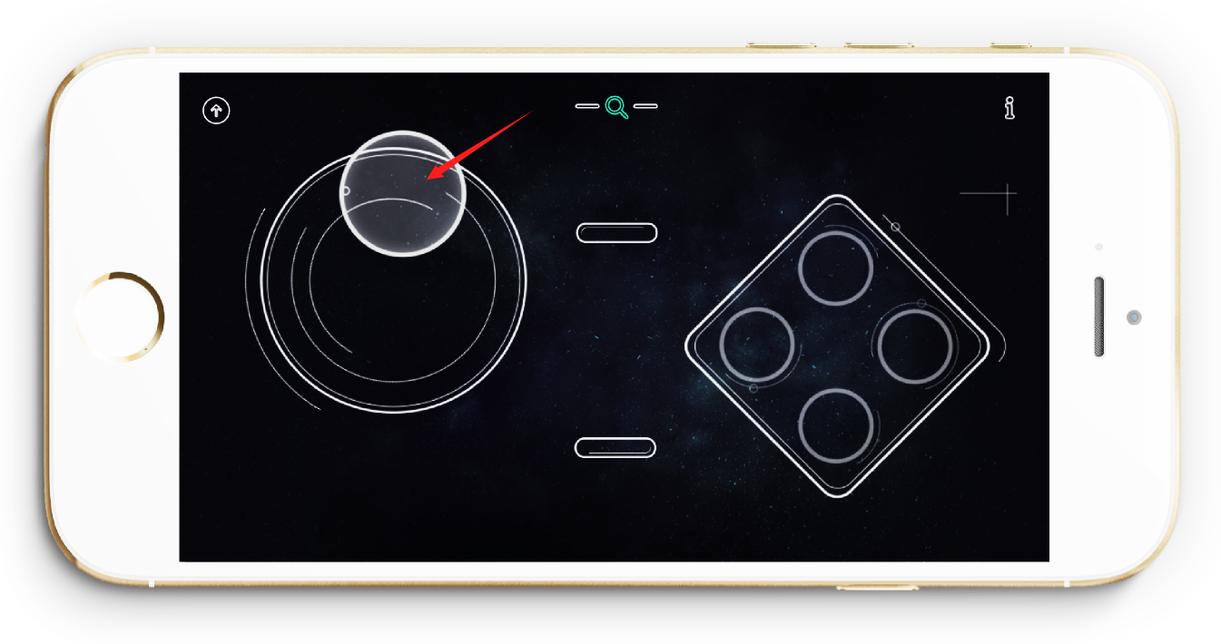

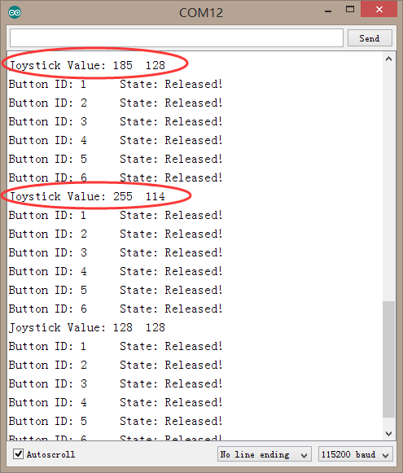

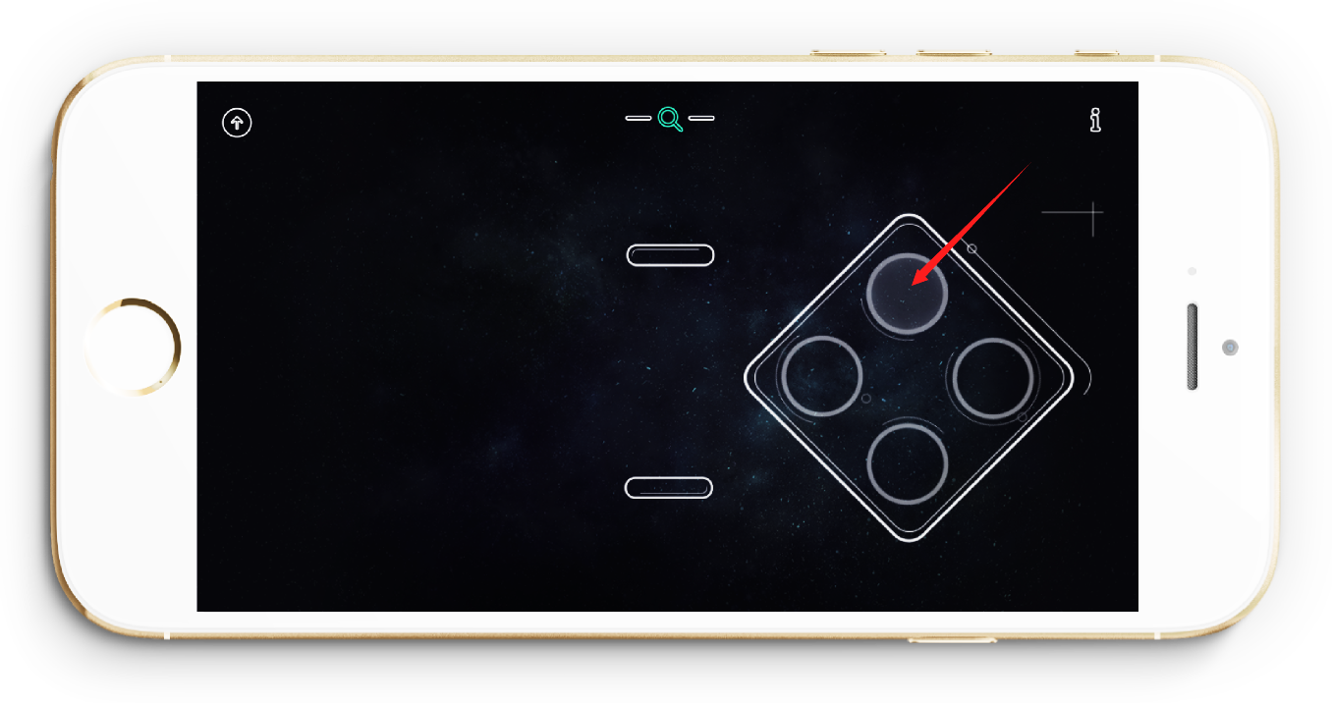

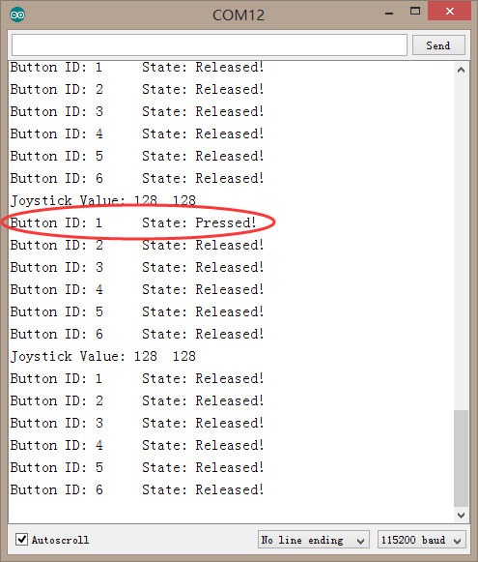

**输入遥控代码**

**Type in the Code for Remote Control**

如果前面都很顺利的话，我们就可以进行最后的遥控代码的下载了。这里下载遥控代码时，有个很关键的一点需要注意。因为我们前面在测试阶段，已经将手机和Romeo BLE建立连接了。**蓝牙在连接时，是无法下载程序的。所以，需要将蓝牙断开连接后，方可下载重新下载程序。这点需要牢记！**

Now let’s download the code for remote control. Your iPhone has already been connected to Romeo BLE in the last testing stage. However, the code for remote control cannot be downloaded with the remote Bluetooth on. Thus, please BREAK OFF the Bluetooth pairing first.

断开蓝牙连接的方法是：可以给Romeo BLE断电再重新上电，或者关掉手机蓝牙。

You can simply turn off the Remeo BLE and then turn it on again or just turn off the Bluetooth on your phone.

断掉蓝牙后，我们重新下载下面这段遥控代码，可在代码包中找到GoBLE_APP.ino。

Now please find GoBLE AOO.ino in the code package.

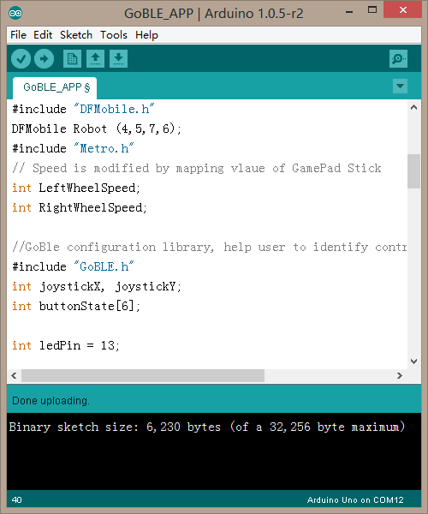

下载成功后，按下图箭头方向前后左右滑动摇杆，就可以通过手机来操控你的机器人。还可按下图中标出的按键，用来控制板载的13号引脚的LED的开关。

Once downloaded, please follow the red arrow in the photo below and swipe the Joystick to control your robot. Also, you may click the red button to turn on or turn off the switch of LED for the NO.13 pin.

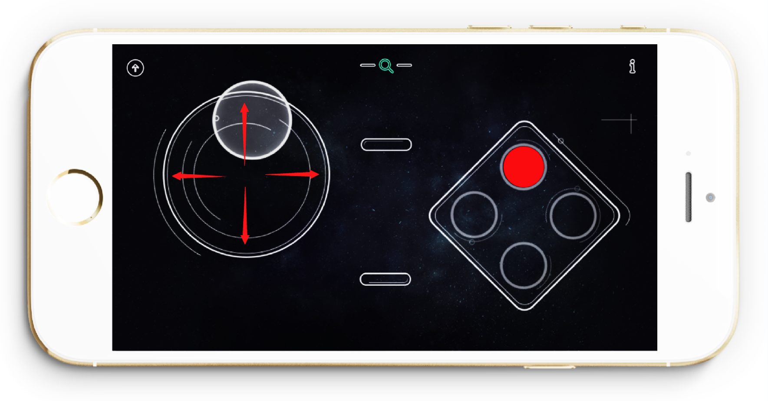

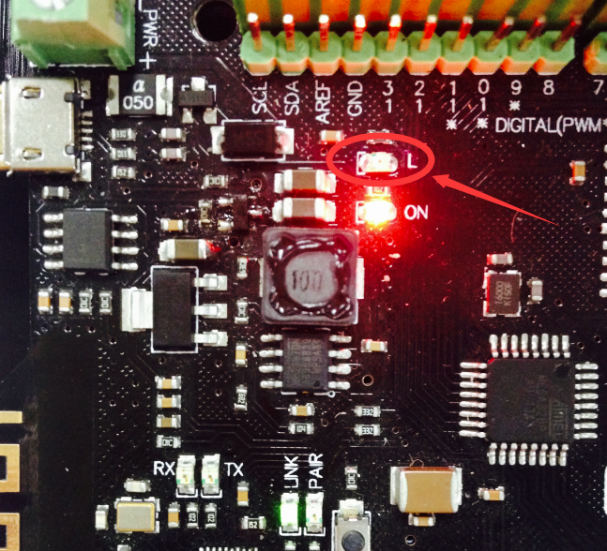

**代码回顾**

**Review of the Code**

小车我们玩过了，现在就来简单学习下代码如何使用了。GoBLE_Test测试代码我们就不单独说了，直接来看下GoBLE_APP。

Let’s start learning how to use the code. No more words for the testing code for GoBLE test. Let’s talk about the GoBLE APP.

基础功能重复的就不多说了，直接说蓝牙遥控的部分。首先，这里用到两个库，Metro和GoBLE库。

For remote control of the robot, two KUs named Metro and GoBLE will be used.

#include "Metro.h"

#include "GoBLE.h"

int joystickX, joystickY;

int buttonState[6];

joystickX，joystickY，buttonState[6]这三个变量是针对GoBLE库定义的。分别用来存储摇杆X轴,Y轴以及6个按键的状态值的。

joystickX, joystickY and buttonState[6], three variables, are defined for the KU, GoBLE. They are used to store the state value for the X-axis, Y-axis and those six buttons respectively.

下图就是各个按键的分布图。如果在测试代码中，有仔细看过数值变化过程的伙伴，也许能猜出左边摇杆图的中的+X,-X,+Y,-Y是什么意思了。

The map below shows the layout of all buttons. You may probably know the meanings of +X,-X,+Y, and –Y if you have analyzed the change of the state values.

X,Y是摇杆的两个移动方向。“+，-”表示的数值的变化趋势。“+”代表数值递增的方向，“-”代表数值递减的方向。

X & Y are the Joystick’s directions of movement. “+”means the state value is increasing and “-”means the state value is decreasing.

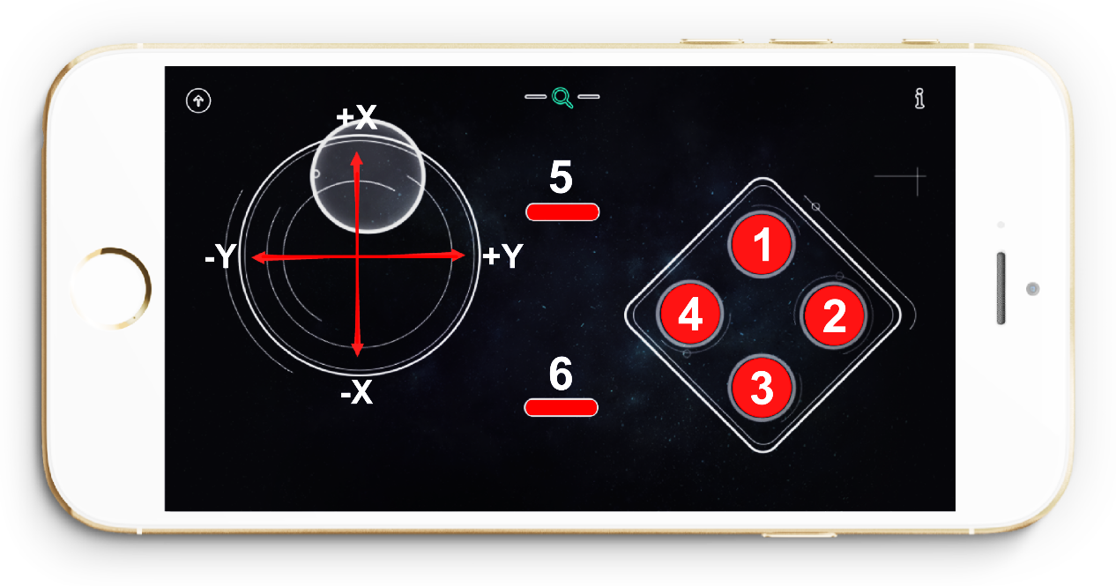

Setup()函数中我们需要做一些初始化设置：

Initiation set-up shall be written in the function of Setup().

Goble.begin();

这句语句用来蓝牙初始化设置的。每次使用手机蓝牙的话，都必须用到这句语句。

It is used for initiating the bluetooth setup. And it cannot be missed out whenever you use the Bluetooth on your phone.

Serial.begin(115200);

这个用法其实我们在前面测试阶段已经用到过了，是用来初始化串口的。如果我们想从串口监视器上看到数据，必须要在setup()函数中，begin一下Serial，并且设置一下它的速度(括号内的值)， **蓝牙波特率为115200。**

It is used to initiating the serial port. Only if it is written in the function of setup(), can we see the figure on the Serial Monitor.

继续往下看，Goble.available()函数：

Next, the function of Goble.available()

if(Goble.available()){

do something;

}

这个函数的含义是：如果接收到了蓝牙发过来的数值，那么执行些什么动作。

Meaning that what the next action is once the figure has been received via Bluetooth.

那么available()内部就是需要执行的动作了。首先，我们需要对接收到的数据做解析，下面两句就是读取X,Y轴上的数据。

What’s written within the brackets would be our next action. First, we need to analyze the figure received.

joystickX = Goble.readJoystickX();

joystickY = Goble.readJoystickY();

// Serial.print("joystickX: ");

// Serial.print(joystickX);

// Serial.print("joystickY: ");

// Serial.println(joystickX);

下面的四句Serial.print()能猜出是什么意思呢？和串口有关。是用来串口打印出读到的数据，便于我们观察，调试。语句前面的”//”符号，表示这句话注释掉。代码在编译的时候，将不包含这四句话。简单的说 ，注释掉这四句话的话，我们无法从串口读到数据。

Guess what the four expressions above mean. It’s for the serial port to print the figures received, which is convenient for our observation and tune-up. ”//”means annotation of the following content. These four sentences won’t be included when compiling the code. Namely, no figures will be sent to the serial port once we annotate these four sentences.

想了解更多，可查看[Arudino语法手册](http://wiki.dfrobot.com.cn/index.php/Arduino%E7%BC%96%E7%A8%8B%E5%8F%82%E8%80%83%E6%89%8B%E5%86%8C%EF%BC%88%E5%A4%9A%E9%A1%B5%E9%9D%A2%E7%89%88%EF%BC%89)。

Please refer to the Arudino Handbook for further information.

buttonState[SWITCH_UP] = Goble.readSwitchUp();

buttonState[SWITCH_DOWN] = Goble.readSwitchDown();

buttonState[SWITCH_LEFT] = Goble.readSwitchLeft();

buttonState[SWITCH_RIGHT] = Goble.readSwitchRight();

buttonState[SWITCH_SELECT] = Goble.readSwitchSelect();

buttonState[SWITCH_START] = Goble.readSwitchStart();

上面这一大串是用来读取按键的状态的。依次对应按键的分布图：

All contents above are used to load the information about the state of the buttons.

Layout of the buttons is as follows.

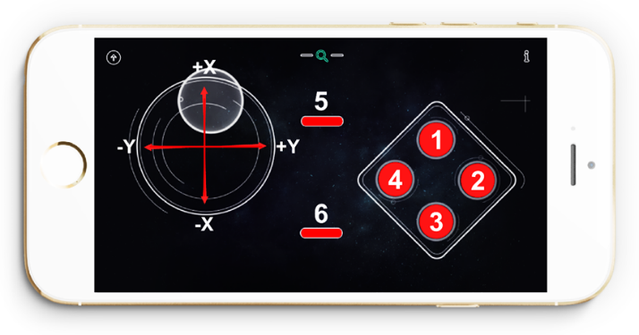

SWITCH_UP (上键) -- 1

SWITCH_RIGHT (右键) -- 2

SWITCH_DOWN （下键） -- 3

SWITCH_LEFT （左键） -- 4

SWITCH_SELECT （选择键） -- 5

SWITCH_START （开始键） -- 6

读完所有的数据以后，我们不能直接拿来用，需要做一些处理。

We need to process all the figures read before we starting using them.

首先，需要将手柄读到的数据映射到我们小车的轮子转速上，所以就有了下面这两句。将读到的原始数据0~255映射为小车速度-255~255。

Figures read on the Joystick shall be mapped to the rotational speed of the wheels of our robot. Thus, rotational speed of the wheels turns out to be between -255 and 255.

int SpeedX=2*joystickX-256;

int SpeedY=2*joystickY-256;

Serial.print("Speed: ");

Serial.print(SpeedX);

Serial.print(" ");

Serial.println(SpeedY);

同样是串口打印出速度，便于你调试使用，如果不需要的话，你也可以用”//”注释掉。

Also the serial port would print out the speed. If unnecessary, you may add ”//” at the beginning to remove it.

数据处理完之后，就需要让小车开始执行动作了。

Now let’s control the robot and make it move.

如果 ( 摇杆向上 或者(||) 摇杆向下 ){

If ( move the Joystick upwards or (||) downwards ){

小车前进或者后退;

The car would move forward or backwards

}

如果 ( 摇杆向右 或者(||) 摇杆向左){

If ( move the Joystick to the right or (||) to the left){

小车右转或者左转;

The car would move to the right or to the left

}

如果 (摇杆X轴没变化 并且(&&) 摇杆Y轴没变化){

If ( X-axis of the Joystick hasn’t changed and (&&) X-axis of the Joystick remains the same ){

小车停止;

The car stops;

}

“翻译”成对应的代码就是下面这段：

Correspondent codes are as follows:

if (SpeedX>200 || SpeedX<-200){

LeftWheelSpeed=SpeedX;

RightWheelSpeed=SpeedX;

Robot.Speed (LeftWheelSpeed,RightWheelSpeed);

}

else if (SpeedY>200 || SpeedY<-200){

LeftWheelSpeed=SpeedY-80;

RightWheelSpeed=-SpeedY-80;

Robot.Speed(LeftWheelSpeed,RightWheelSpeed);

}

else if (SpeedX==0 && SpeedY==0){

Robot.Speed(0,0);

}

最后一段是用来控制板的是板载13号引脚的LED。

int ledPin = 13;

代码开始还是需要定义下13号引脚。

No.13 pin should be define at the beginning of the code.

pinMode(ledPin,OUTPUT);

在setup()中将LED设置为输出模式，具体可以查看[pinMode()函数](http://wiki.dfrobot.com.cn/index.php/PinMode())的使用说明。

Set up output mode for LED by writing the function of setup(). Please refer to instruction for the function of pinMode().

下面这段就是对按键读到的状态进行判断，因为我们只用到了按键1(上键)，如果被按下了(PRESSED)，点亮LED,也就是将LED引脚设置为HIGH。

The following expressions show the state of the buttons. Once button No.1 has been pressed, LED would be on. Meaning that the LED pin is set to be HIGH.

if (buttonState[1] == PRESSED){

digitalWrite(ledPin,HIGH);

}

同样如果按键被释放(RELEASED),熄灭LED，也就是将LED引脚设置为LOW。

Once button No.1 has been released, LED would be off. Meaning that the LED pin is set to be LOW.

if (buttonState[1] == RELEASED){

digitalWrite(ledPin,LOW);

}

好了，代码解释就到这里了。这样一看，是不是代码也不是很难理解呀？可是尝试按照你的意愿来修改代码，比如换一个按键来控制小灯啦，或者给你小车装个手动转向灯等等。好玩的很多，当看到小车按你的要求在跑的话，一定会觉得非常有乐趣的！

That’s all for coding today. Isn’t it FUN? You can try to change a button to control the LED light by modifying the code. It’s definitely gonna be more interesting. Now, START HAVING FUN with your robot!!!